

**UNIVERSIDAD TECNOLÓGICA DE**

**SAN LUIS RIO COLORADO**

**PRACTICA 5**

**MTRO. RICARDO ALEJANDO SOTO MORALES**

**AUTOR: VICTOR MANUEL GALVAN COVARRUBIAS**

San Luis Rio Colorado, Sonora Julio, 2020

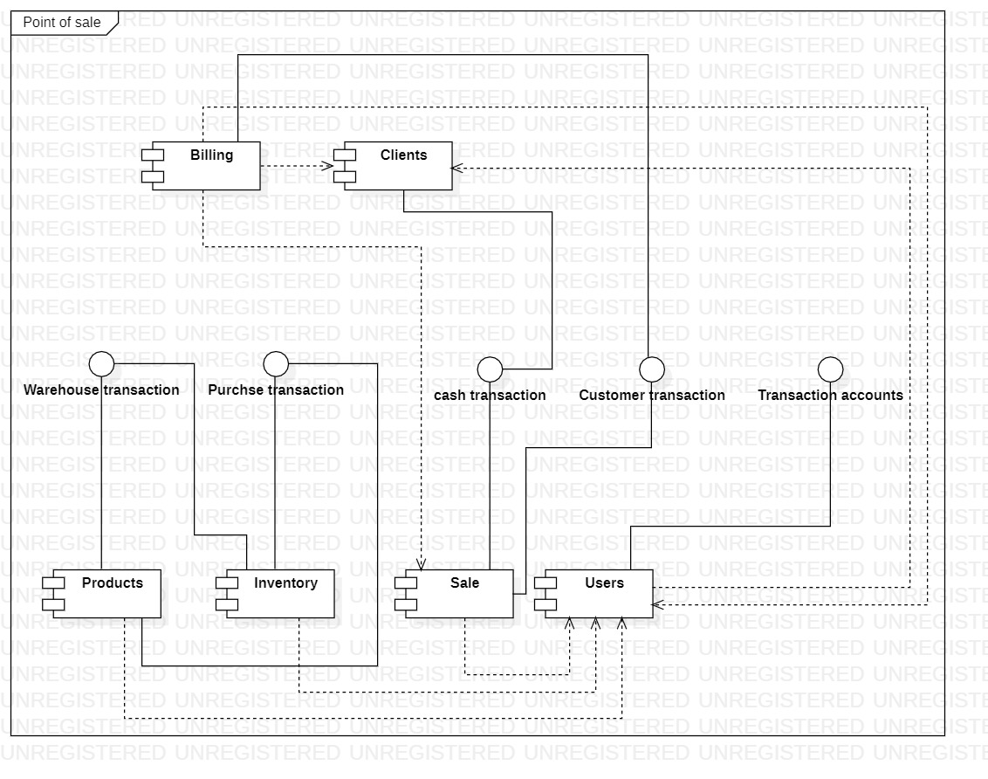

Illustration 1: Components diagram corresponding to a Point of sale.

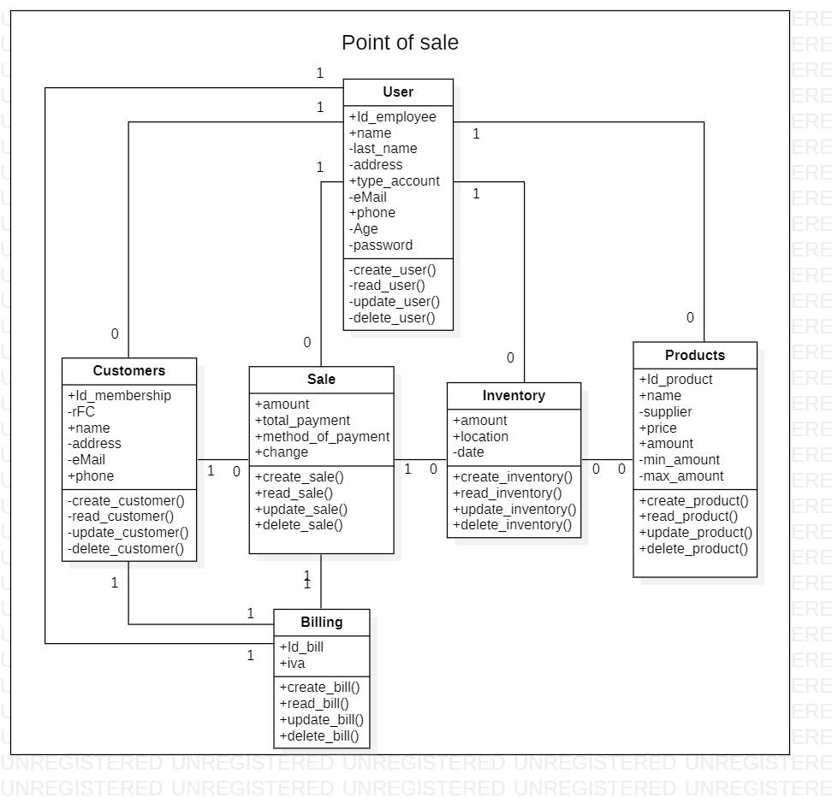

Illustration 2: Class diagram corresponding to a Point of sale.

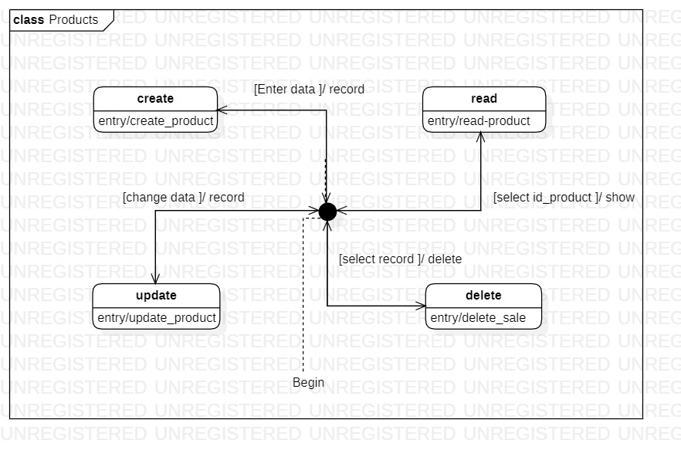

Illustration 3: State diagram corresponding to the class products.

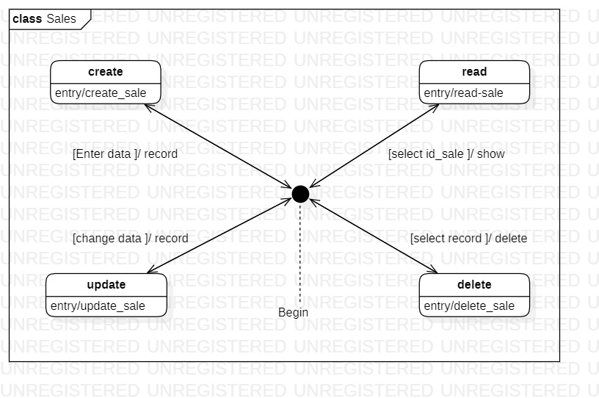

Illustration 1: State diagram corresponding to the class sales.

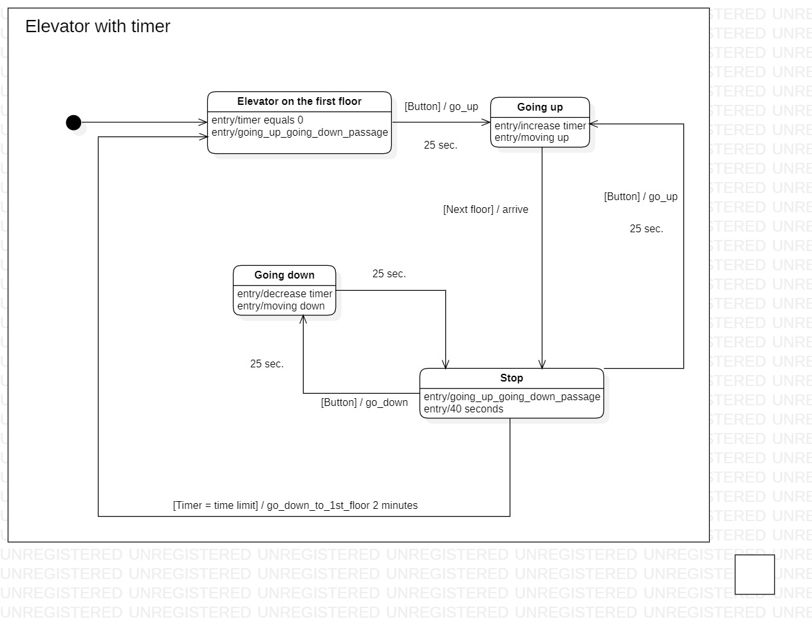

Illustration 5: State diagram corresponding to an elevator with timer.